Year  10 |  | Surface Area and Volume of Other Solids | Calculator Allowed
Skills and Knowledge Assessed:  - Solve problems involving surface area and volume of right pyramids, right cones, spheres and related composite solids (ACMMG271) |  |  | Name_________________
Section 1 Short Answer Section
Write all working and answers in the spaces provided on this test paper.

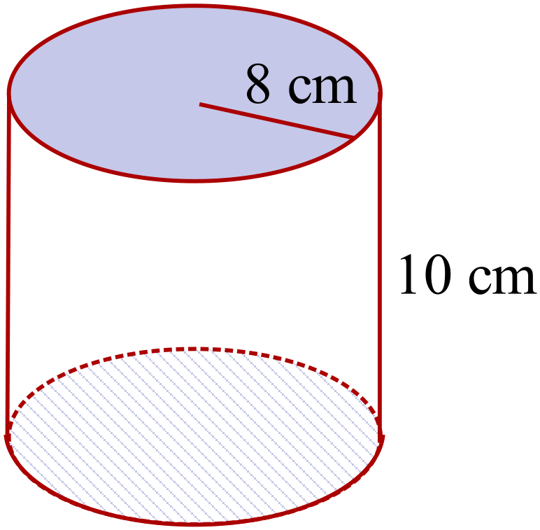Find the volume of the cylinder shown (to the nearest cm).

………………………………………………

……………………………………………….

………………………………………………

……………………………………………….
This solid is made using 2 cm interlocking cubes.
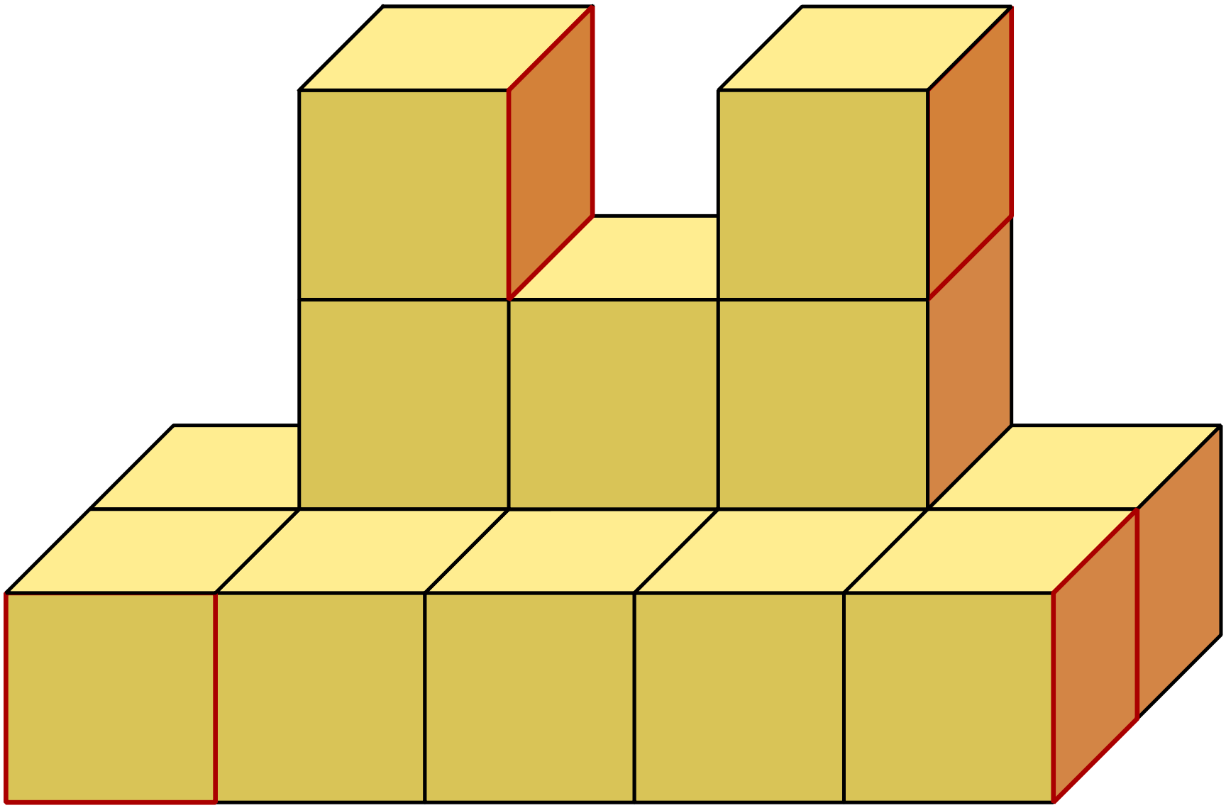
What is the total volume of the solid formed?

………………………………………………

……………………………………………….

………………………………………………

……………………………………………….
The octagonal pyramid is 3.6 m high and its base has an area of 5.4 m². Find its volume.
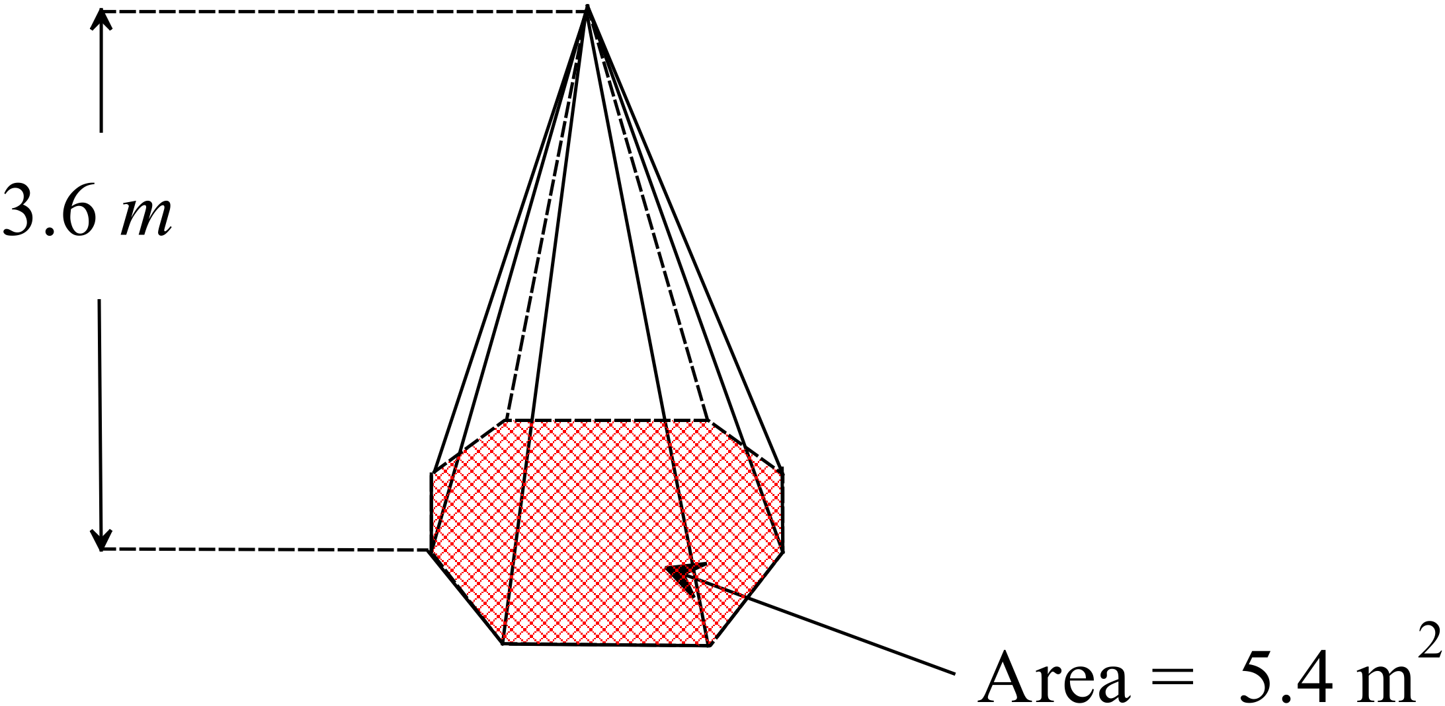
...................................................................

...................................................................

...................................................................

..................................................................

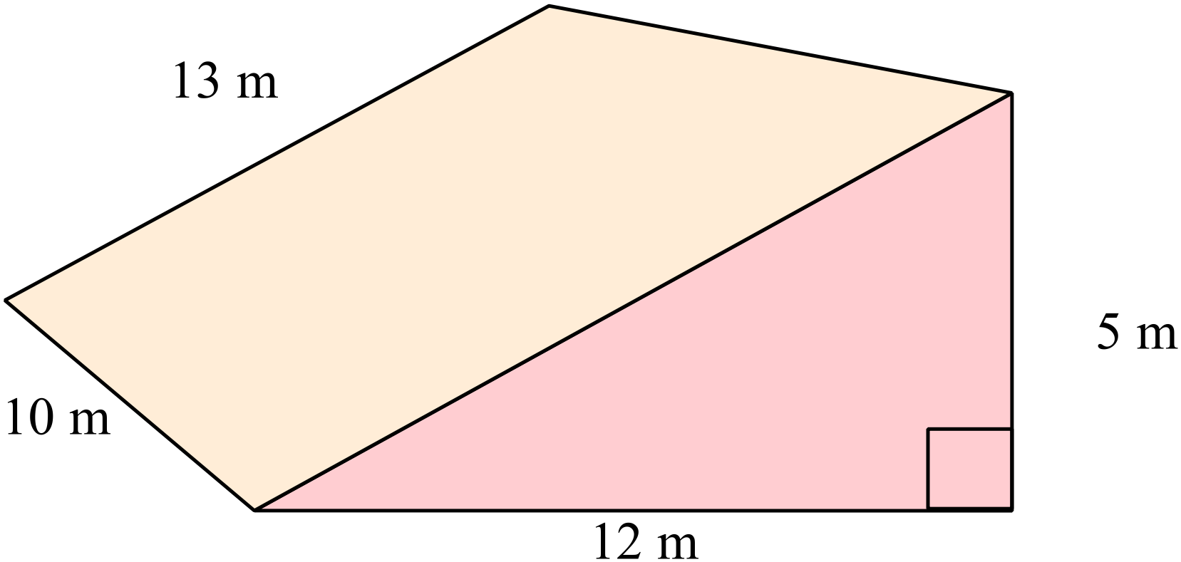What is the surface area of the prism shown in cm²?

………………………………………………

……………………………………………….

………………………………………………

……………………………………………….

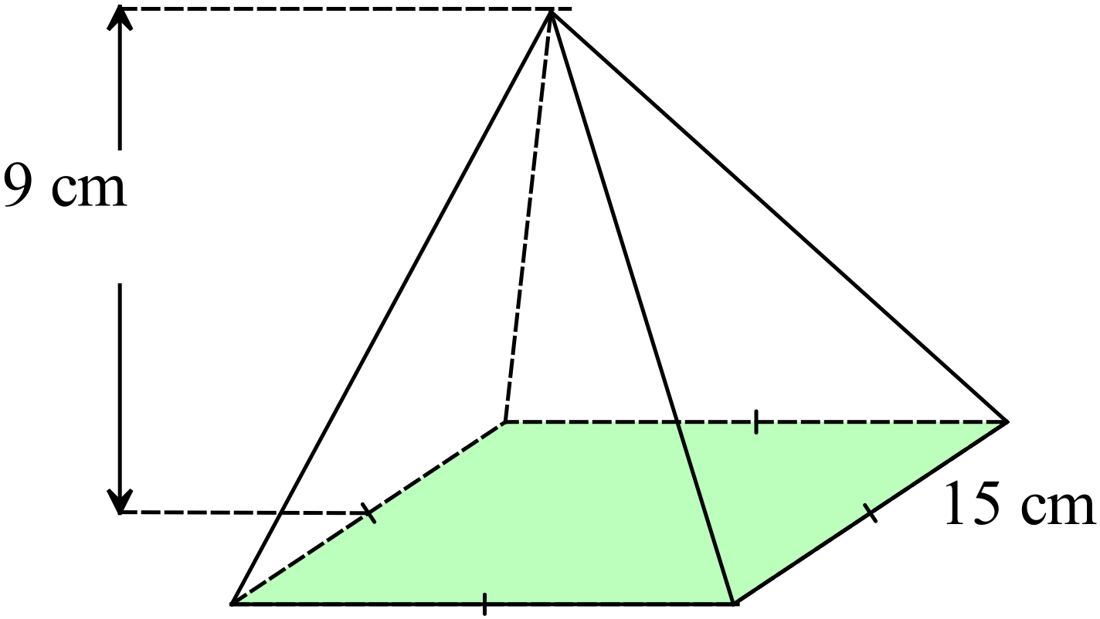What is the volume of the square pyramid?

………………………………………………

……………………………………………….

………………………………………………

……………………………………………….

A water collector for a tank is in the shape of a rectangular pyramid.
How many litres of water can it hold?
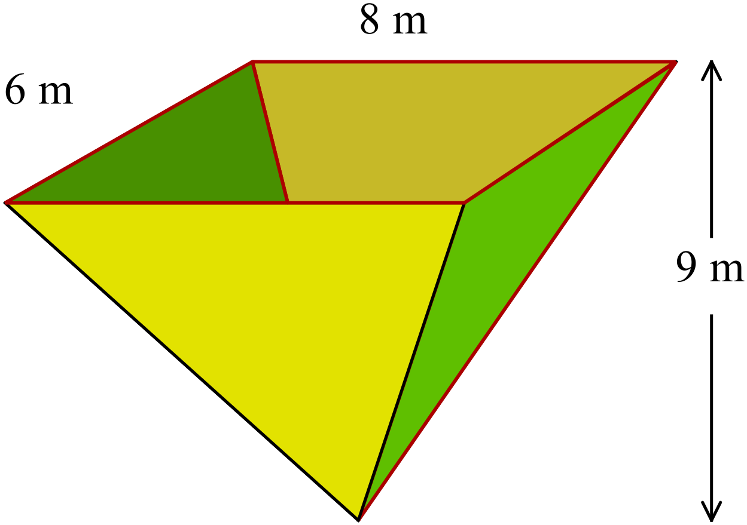
1 m³ holds 1 kilolitre of water.

………………………………………………

……………………………………………….

………………………………………………

……………………………………………….

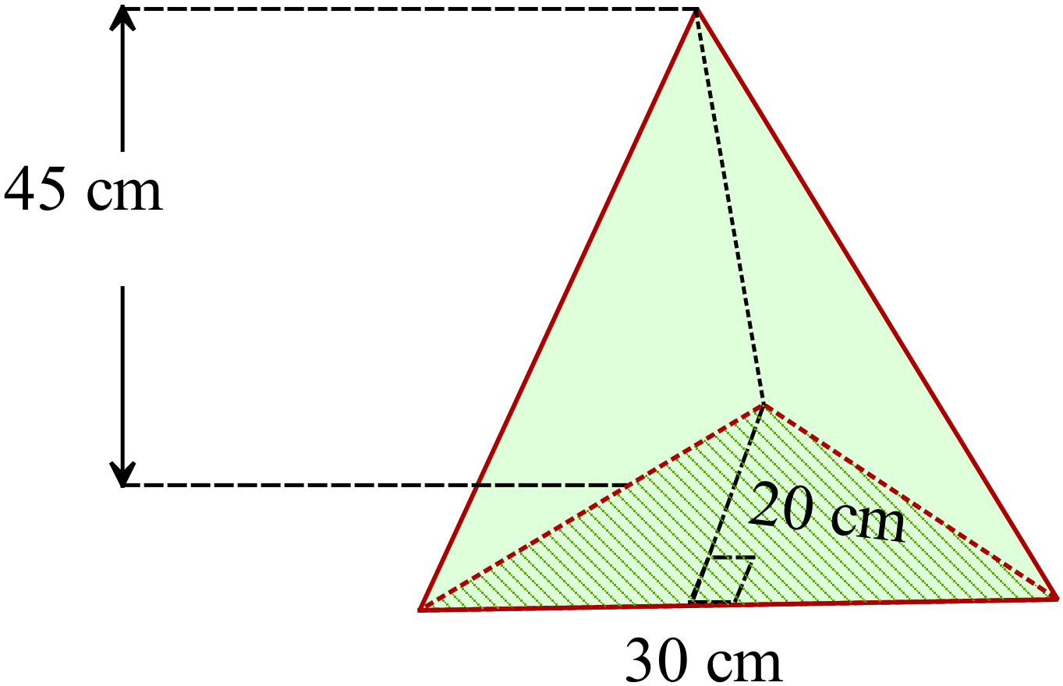Calculate the volume of the triangular prism shown.
...................................................................

...................................................................

...................................................................

..................................................................

What is the volume of the right cone shown (nearest cm³)?
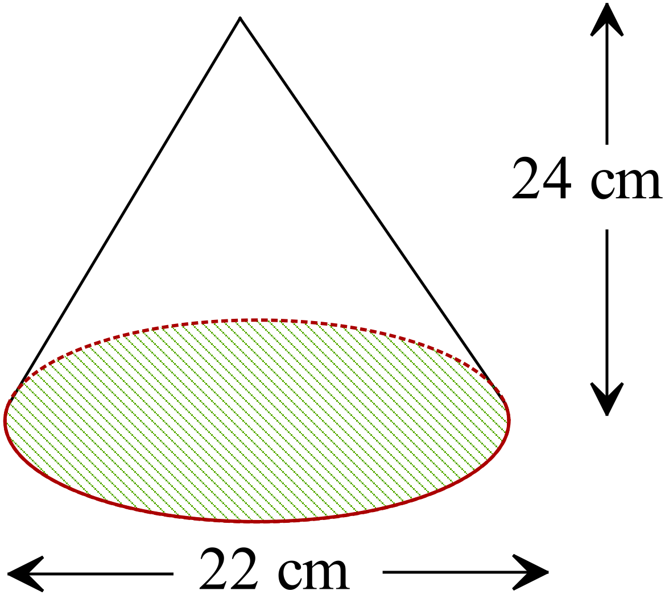

………………………………………………

……………………………………………….

………………………………………………

……………………………………………….

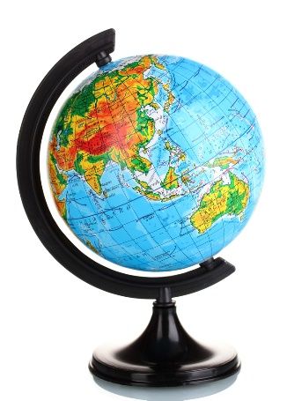
A globe of the earth is a 42 cm diameter sphere.
What is the surface area of the globe?

………………………………………………

……………………………………………….

…….…………………………………………

……………………………………………….
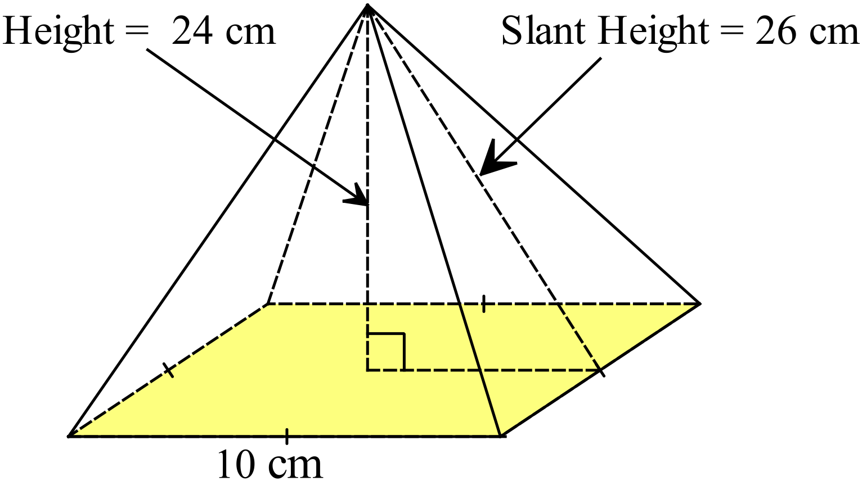What is the surface area of the square pyramid shown?

………………………………………………

……………………………………………….

………………………………………………

……………………………………………….
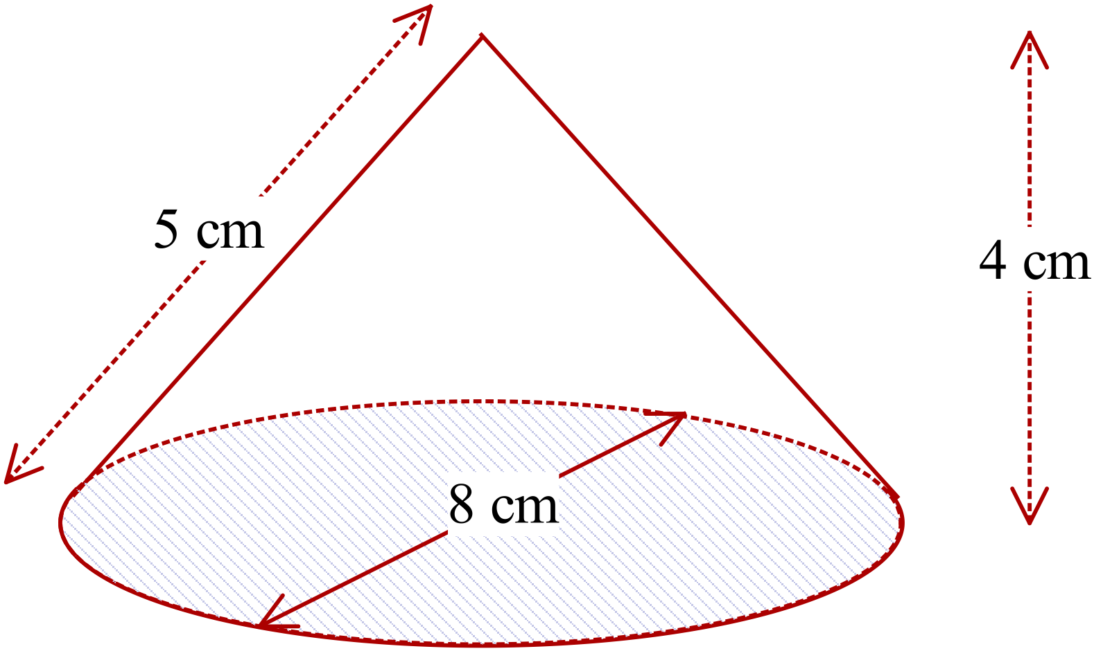What is the surface area of this cone?

….………………………………………

………………………………………….

…………………………………………

………………………………………….

A hemisphere has a radius of 24 mm.
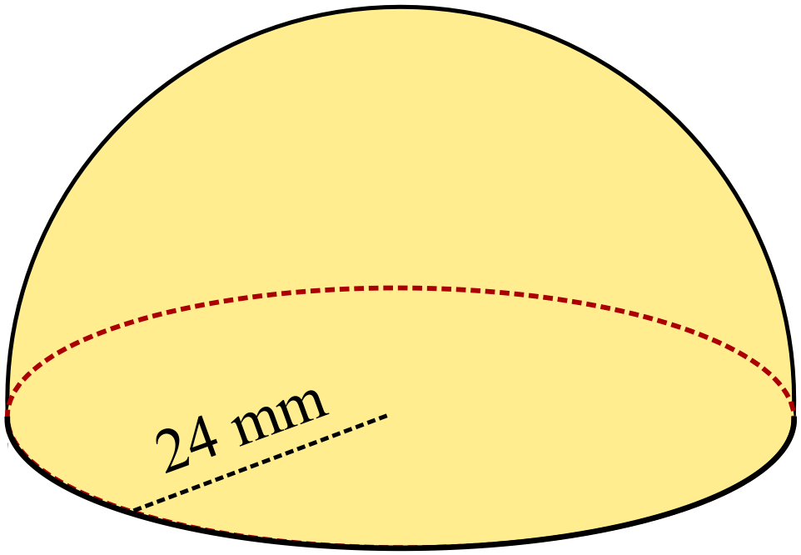What is its volume?

………………………………………………

………………………………………………

……………………………………………….

………………………………………………

Year  10 |  | Surface Area and Volume of Other Solids | Calculator Allowed
 |  | Surface Area and Volume of Other Solids | Name_________________
Section 2 Multiple Choice Section
Mark all your answers on the accompanying multiple choice answer sheet, not on this test paper. You may do any working out on this test paper. Calculators are allowed for this section.

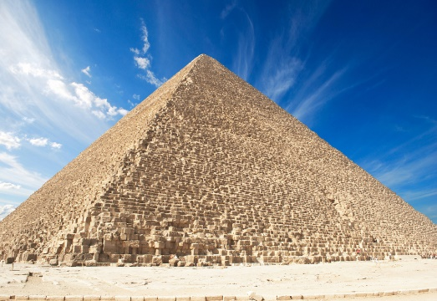
An Egyptian pyramid has a square base 90 m long and is 40 m high. What is its volume?

A. 108 000 m³

B. 180 000 m³

C. 270 000 m³

D. 324 000 m³

A rectangular pyramid has base edges 12 cm and 9 cm and a perpendicular of height 16 cm.
What is its volume?

A. 64 cm³ B. 85 cm³ C. 114 cm³ D. 576 cm³

The formula 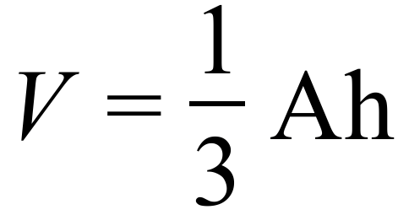 could be applied to which of the solids shown below.
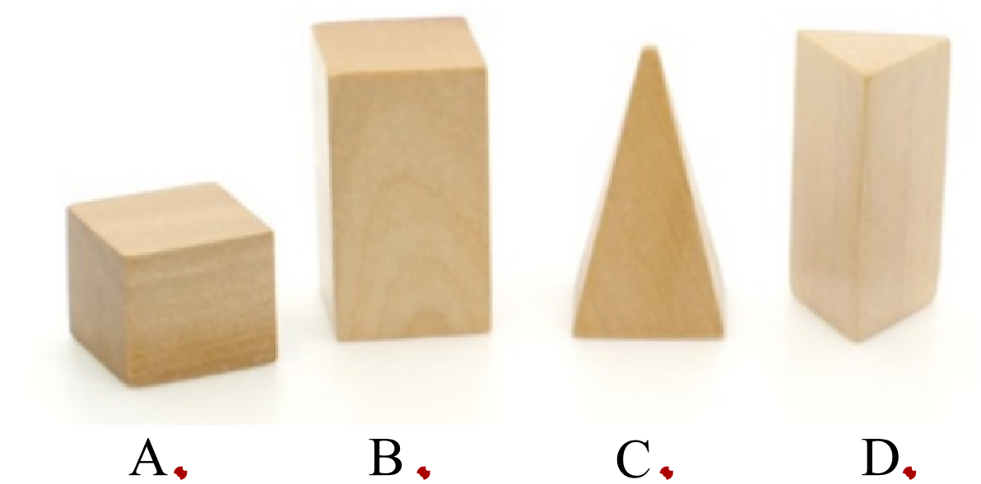

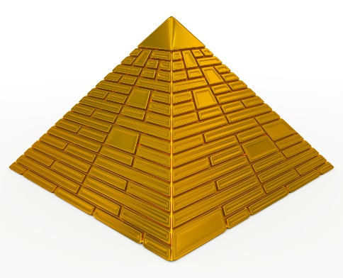
A paperweight is a square pyramid.
Its base measures 15 cm and it is 12 cm tall.
What is its volume?

A. 720 cm³

B. 900 cm³

C. 2160 cm³

D. 2700 cm³

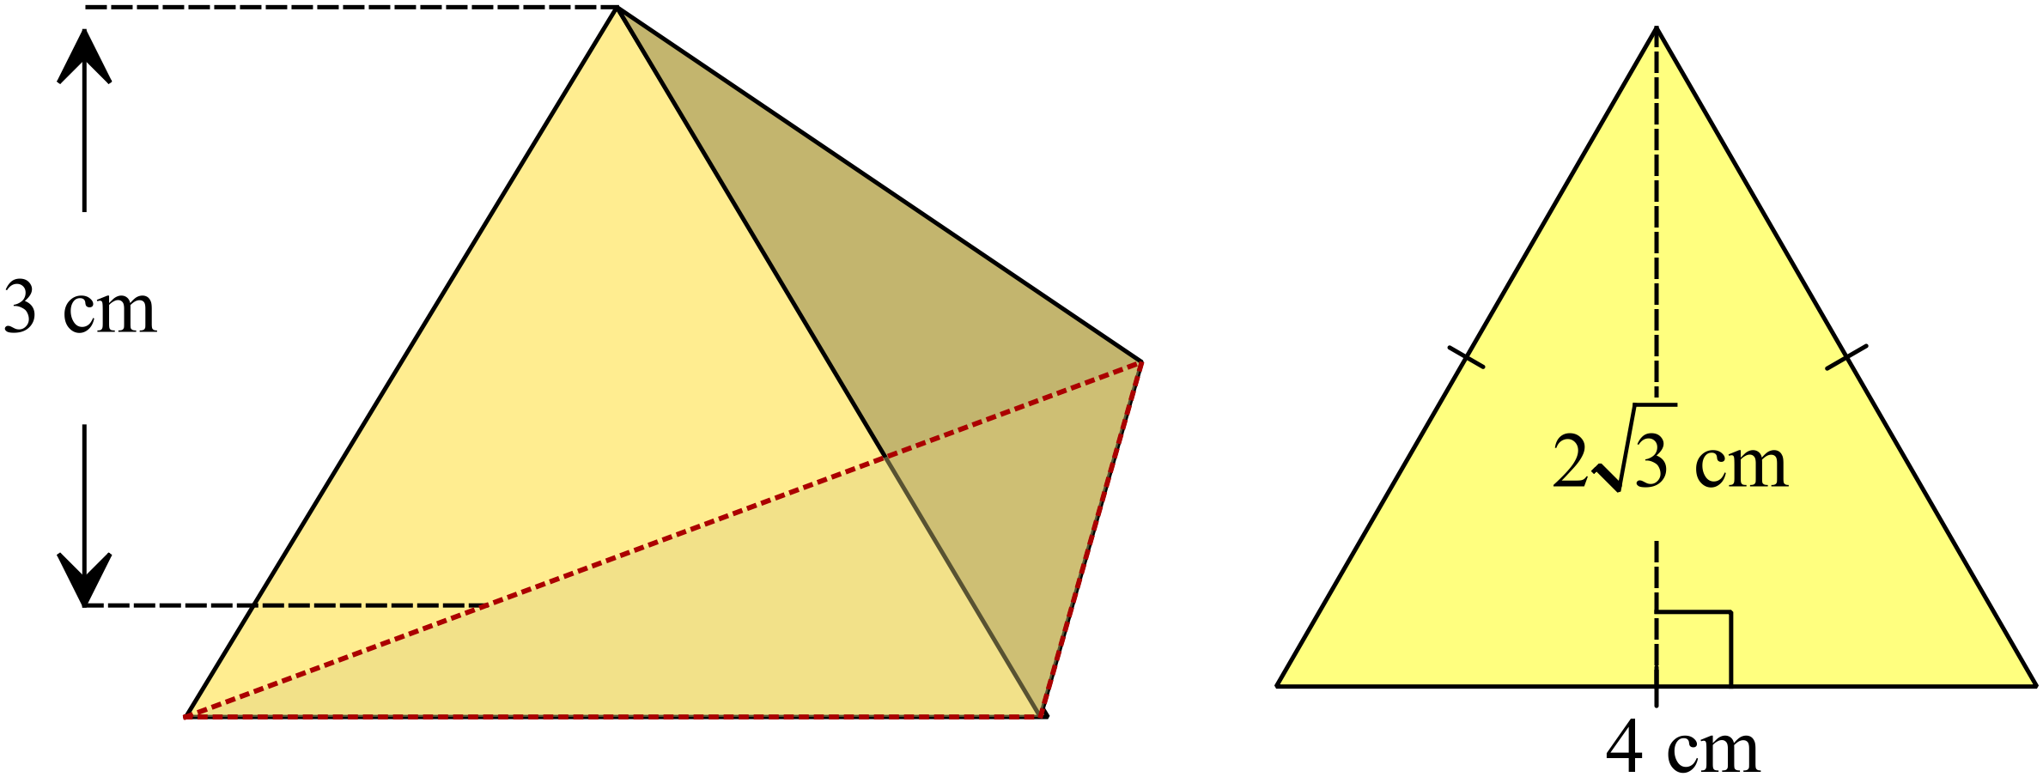A tetrahedron has faces which are equilateral triangles with 4 cm edges as shown far right. The perpendicular height of the tetrahedron is approximately 3 cm.
What is the surface area of the tetrahedron in cm²?

A. 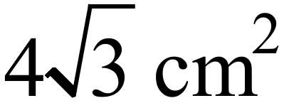 B. 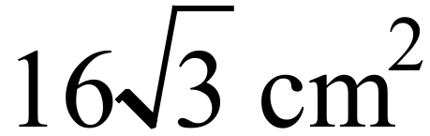

C. 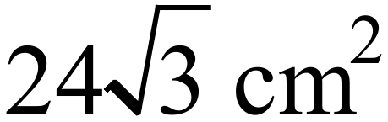 D. 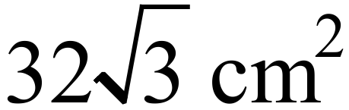

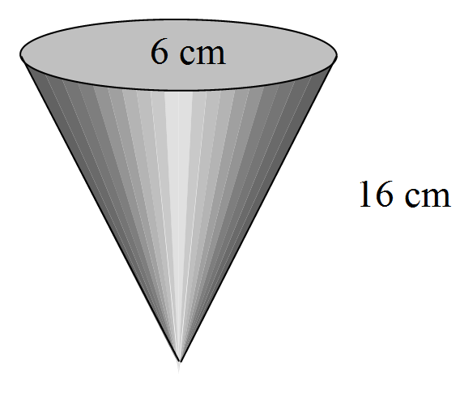
The design for a solid plastic spinning top is in the shape of a cone as shown.
What volume of plastic is needed to make the top?
10 cm

A. 94.2 cm³ B. 188.5 cm³

C. 282.7 cm³ D. 377.0 cm³

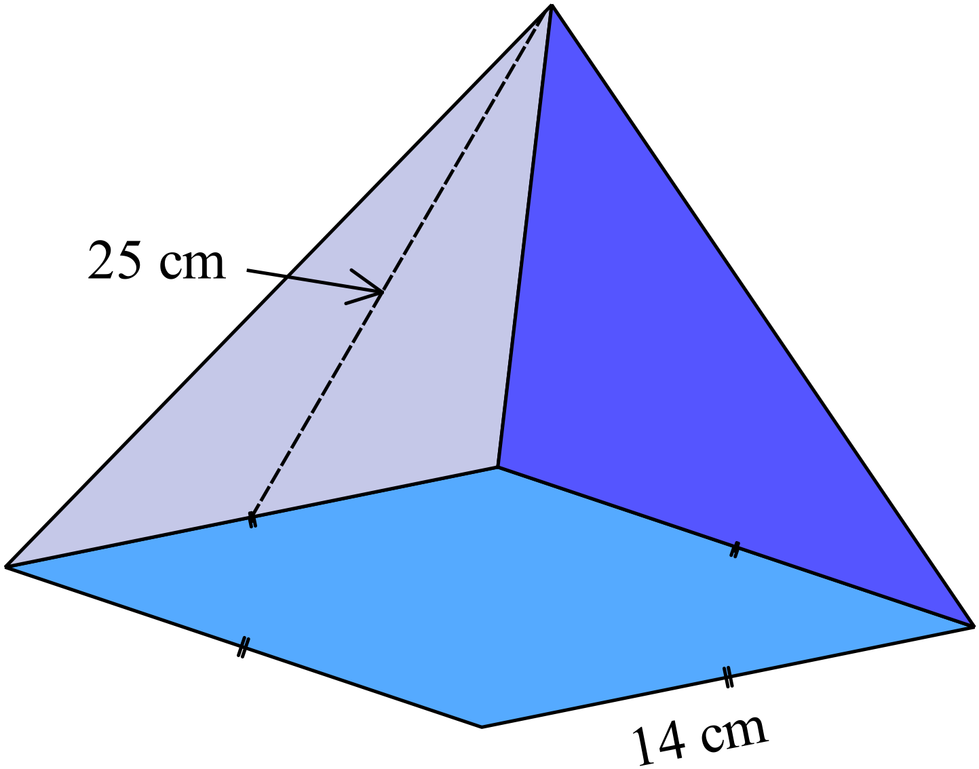What is the surface area of the square pyramid shown?

A. 196 cm²

B. 700 cm²

C. 721 cm²

D. 896 cm²

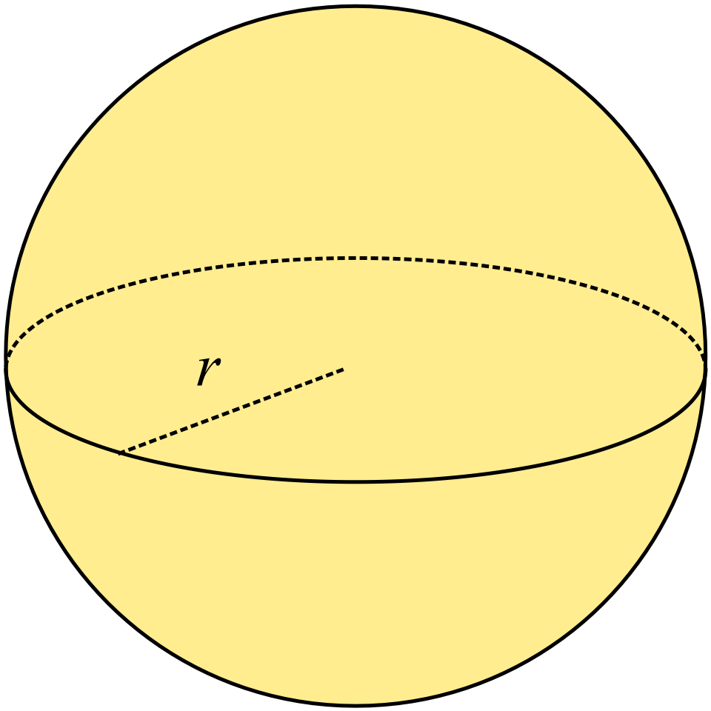A sphere has a volume of 3053 mm.
What is its radius r?

A. 3 cm

B. 6 cm

C. 9 cm

D. 12 cm

The dome on this shrine is hemispherical in shape. Its diameter is approximately 20 m.
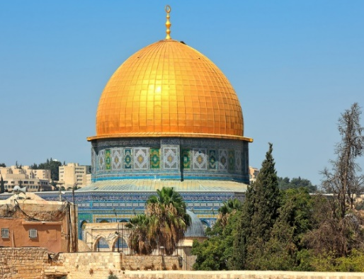
What is the surface area of the dome?

A. 628.3 m²

B. 1 256.6 m²

C. 2 094.4 m²

D. 4 188.7 m²

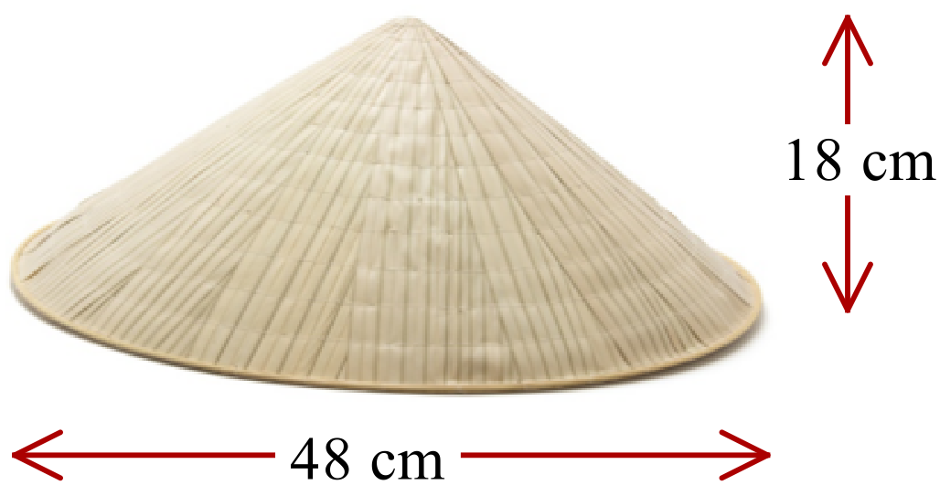A hat is made in the shape of a cone with the dimensions shown.

What is the area of upper surface of the hat?

A. 1 357 cm²

B. 2 262 cm²

C. 4 072 cm²

D. 4 524 cm²

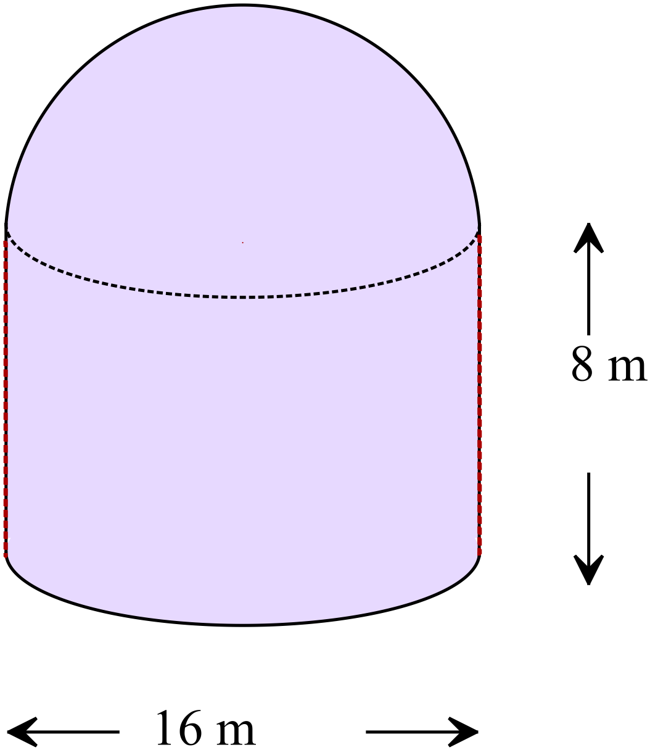The building was designed to house an observatory and has cylindrical walls and a hemispherical roof.
Ignoring the thickness of the walls, what is the volume of the building?

A. 1 072 m³

B. 1 608 m³

C. 2 681 m³

D. 3 753 m³

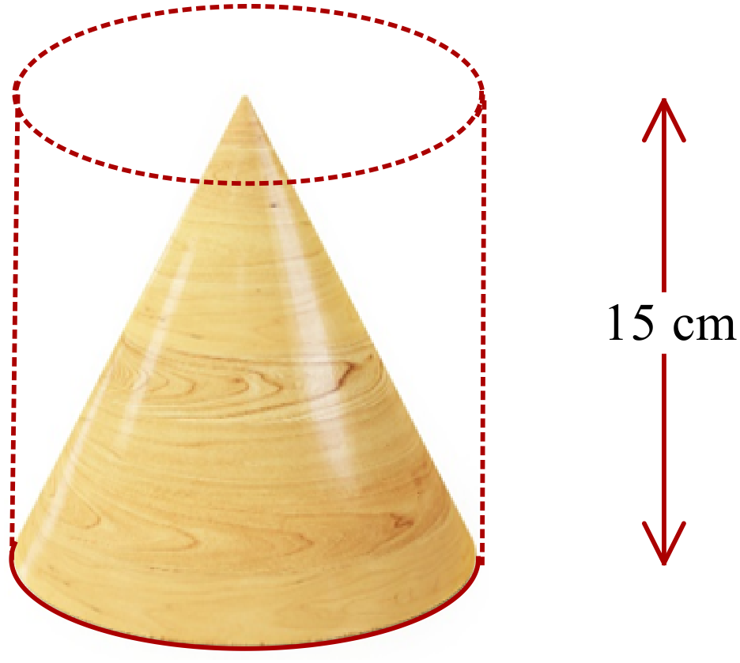Hector uses a lathe to form the cone shown from a cylindrical piece of wood.

The height of the cone and cylinder are both 15 cm and the volume of the cylinder was 1 990 cm³.

What is the surface area of the cone?

A. 6.5 cm²

B. 132.7 cm²

C. 332.9 cm²

D. 466.4 cm²

Surface Area and Volume of Other Solids

Multiple Choice Answer Sheet
Name _____________________________________________
Completely fill the response oval representing the most correct answer.

1. A B C D
2. A B C D
3. A B C D
4. A B C D
5. A B C D
6. A B C D
7. A B C D
8. A B C D
9. A B C D
10. A B C D
11. A B C D
12. A B C D
13. A B C D
14. A B C D
15. A B C D

Surface Area and Volume of Other Solids

ANSWERS
Section 1 ( 1 mark each)
Working and Answers
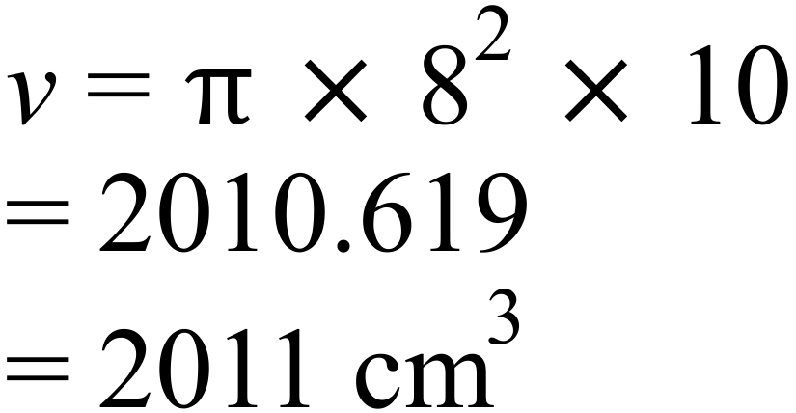
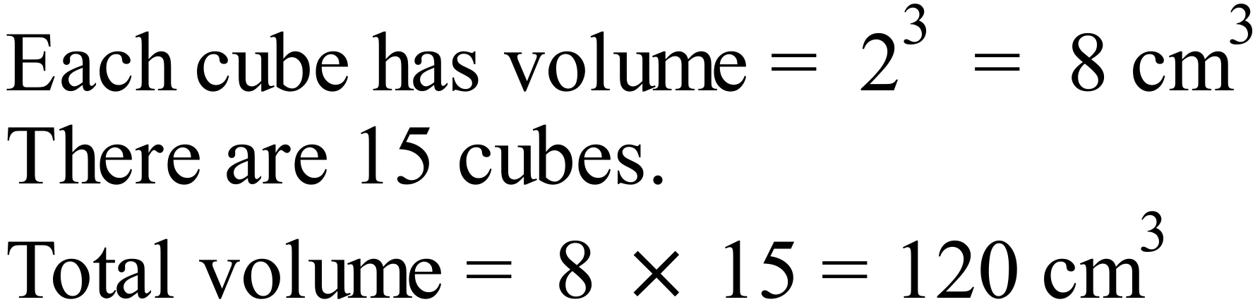
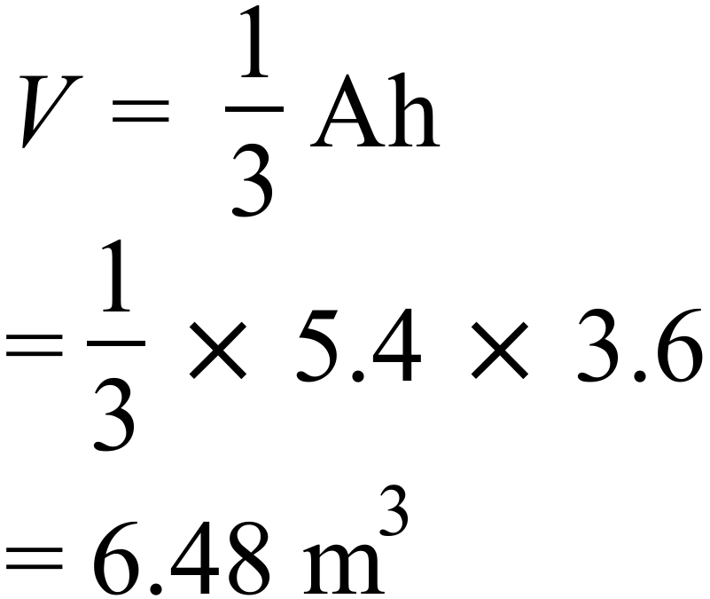
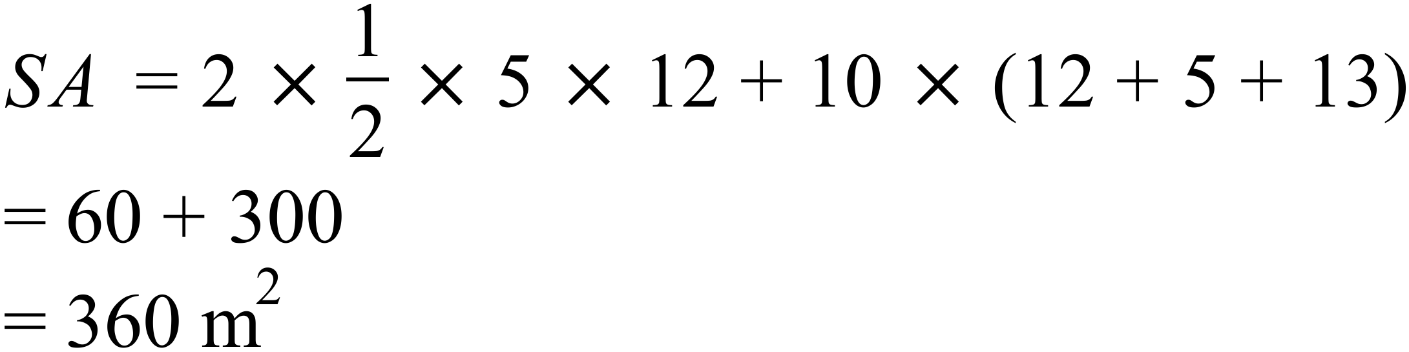
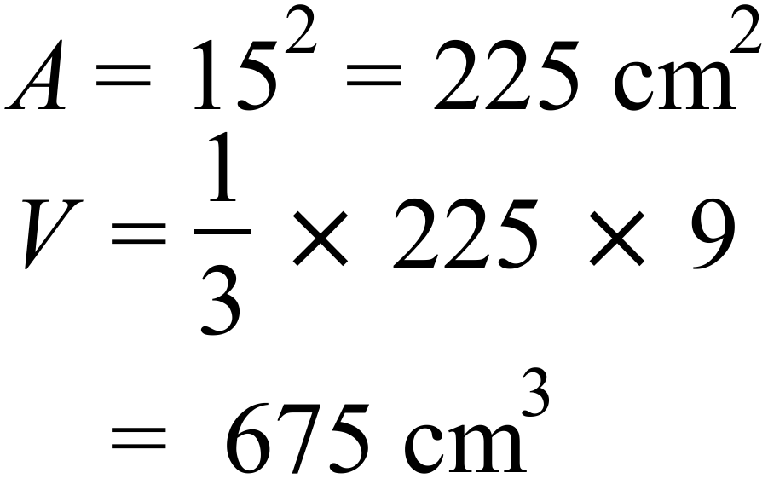
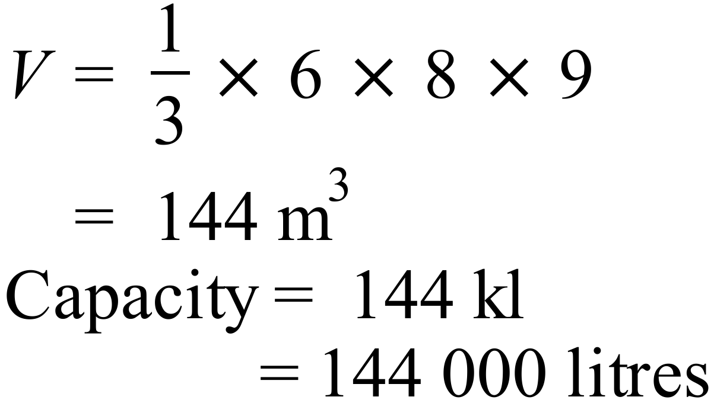
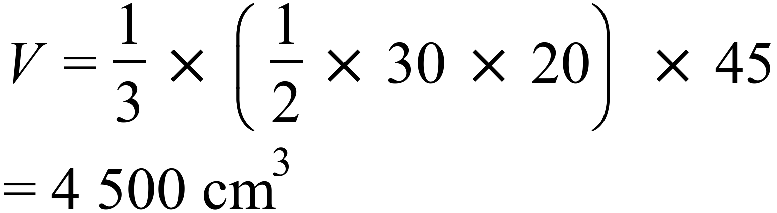
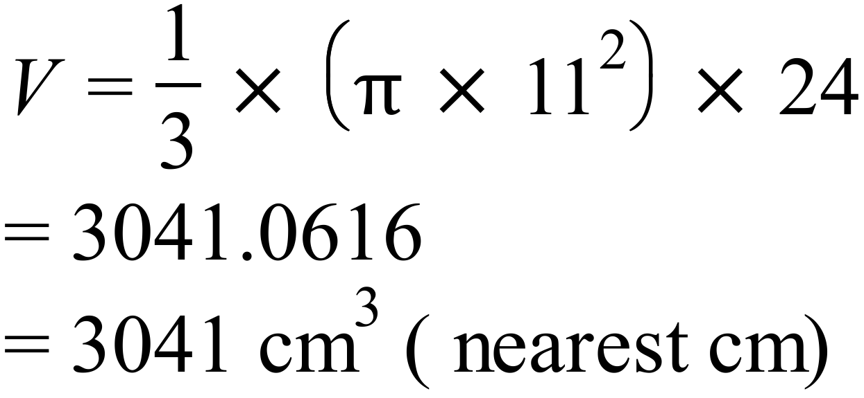
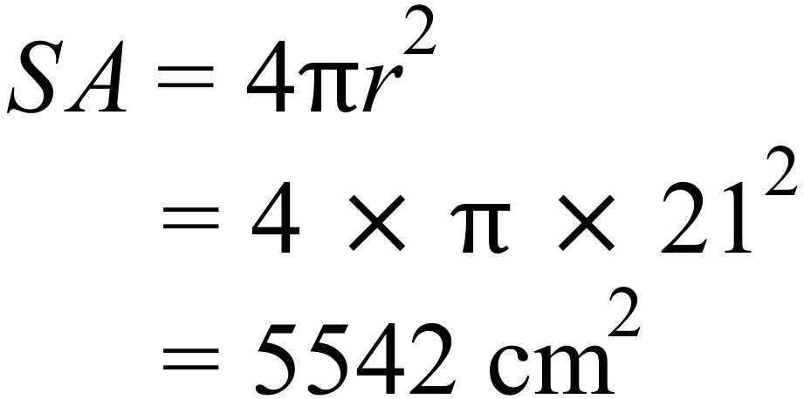
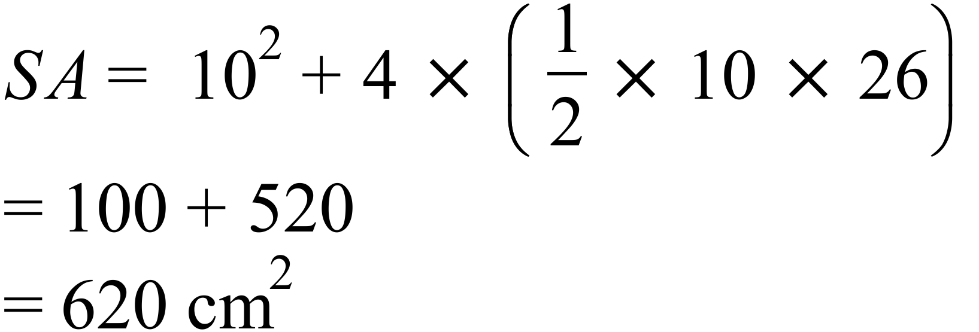
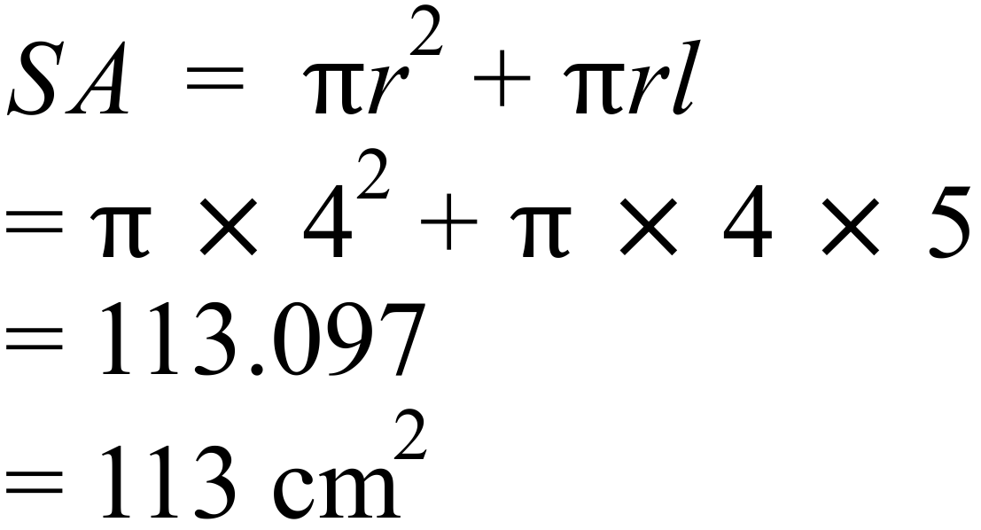
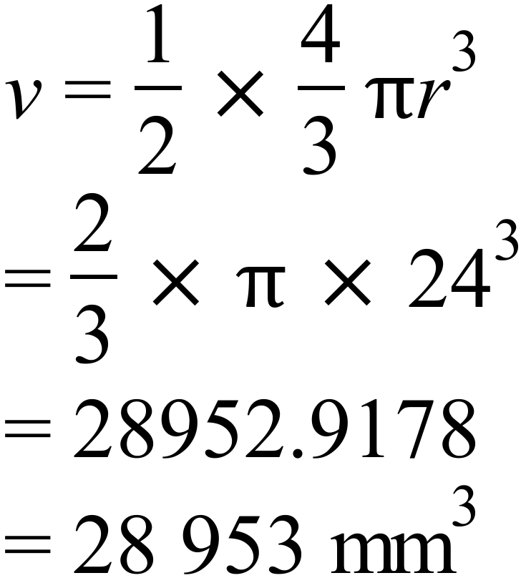

Section 2 (1 mark each)
 | Working | Answers
 | 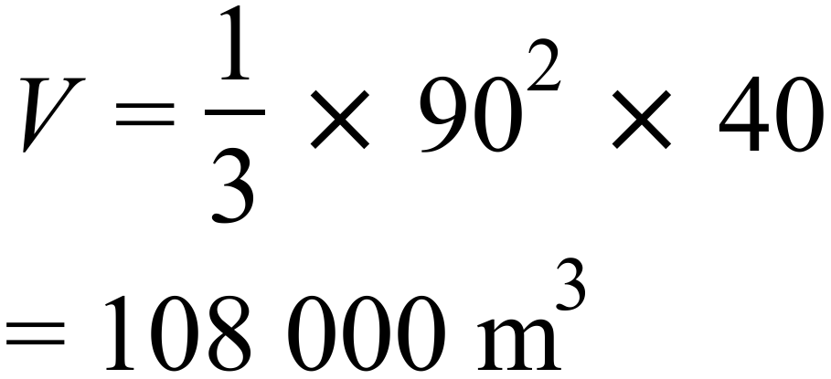 | A
 | 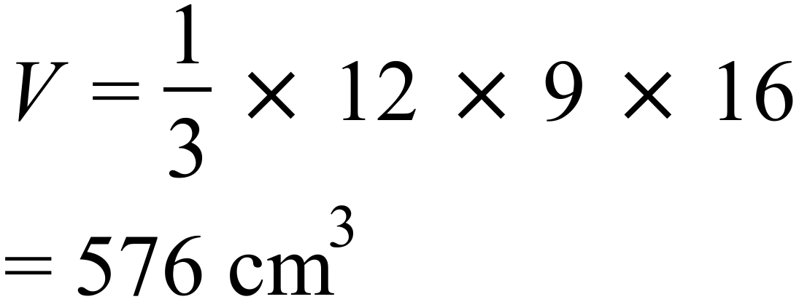 | D
 | C is the only pyramid. | C
 | 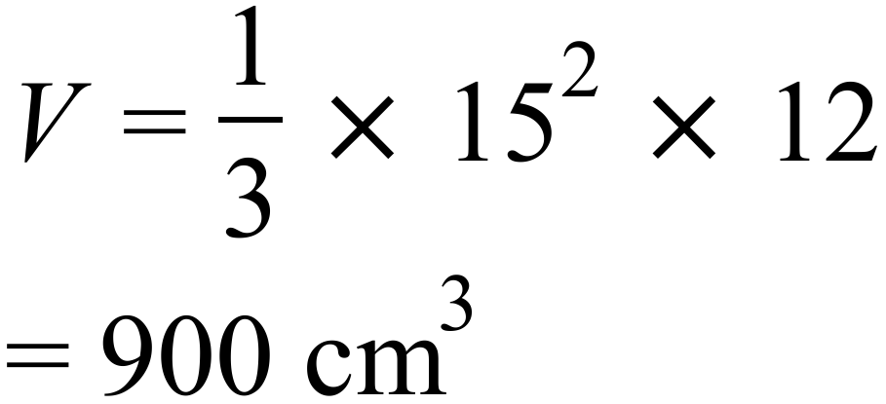 | B
 | 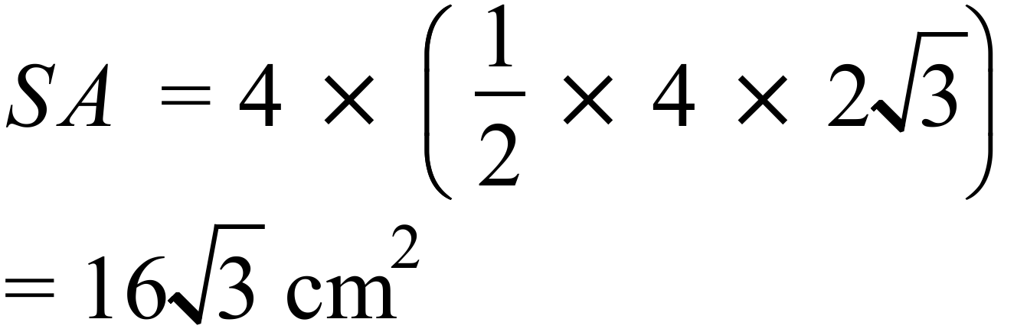 | B
 | 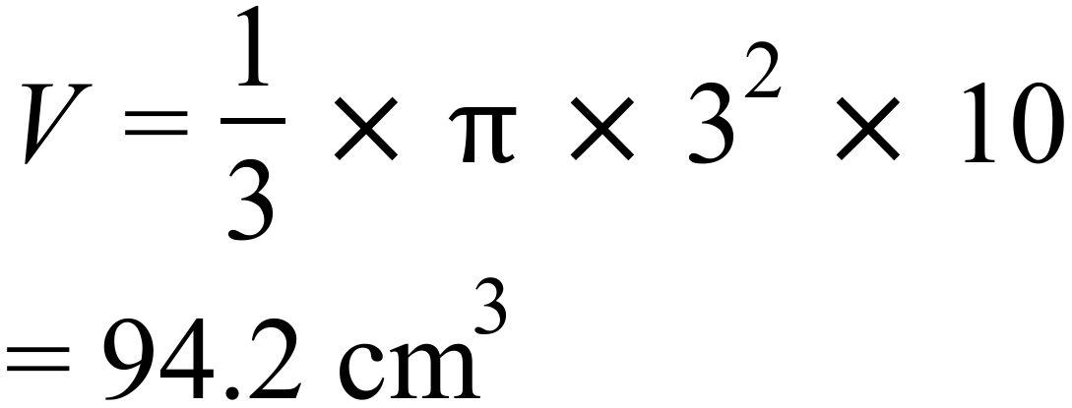 | A
 | 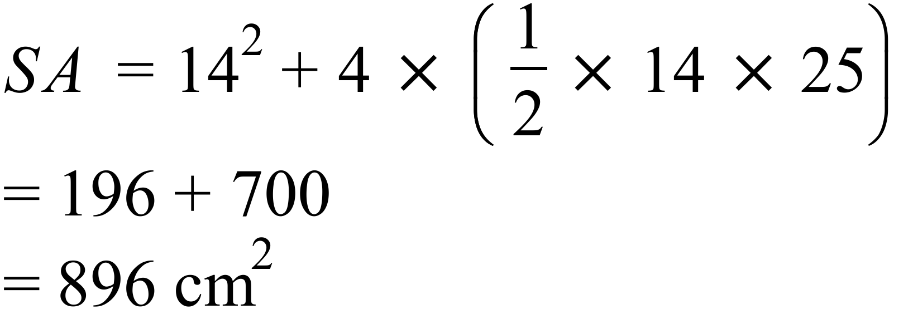 | D
 | 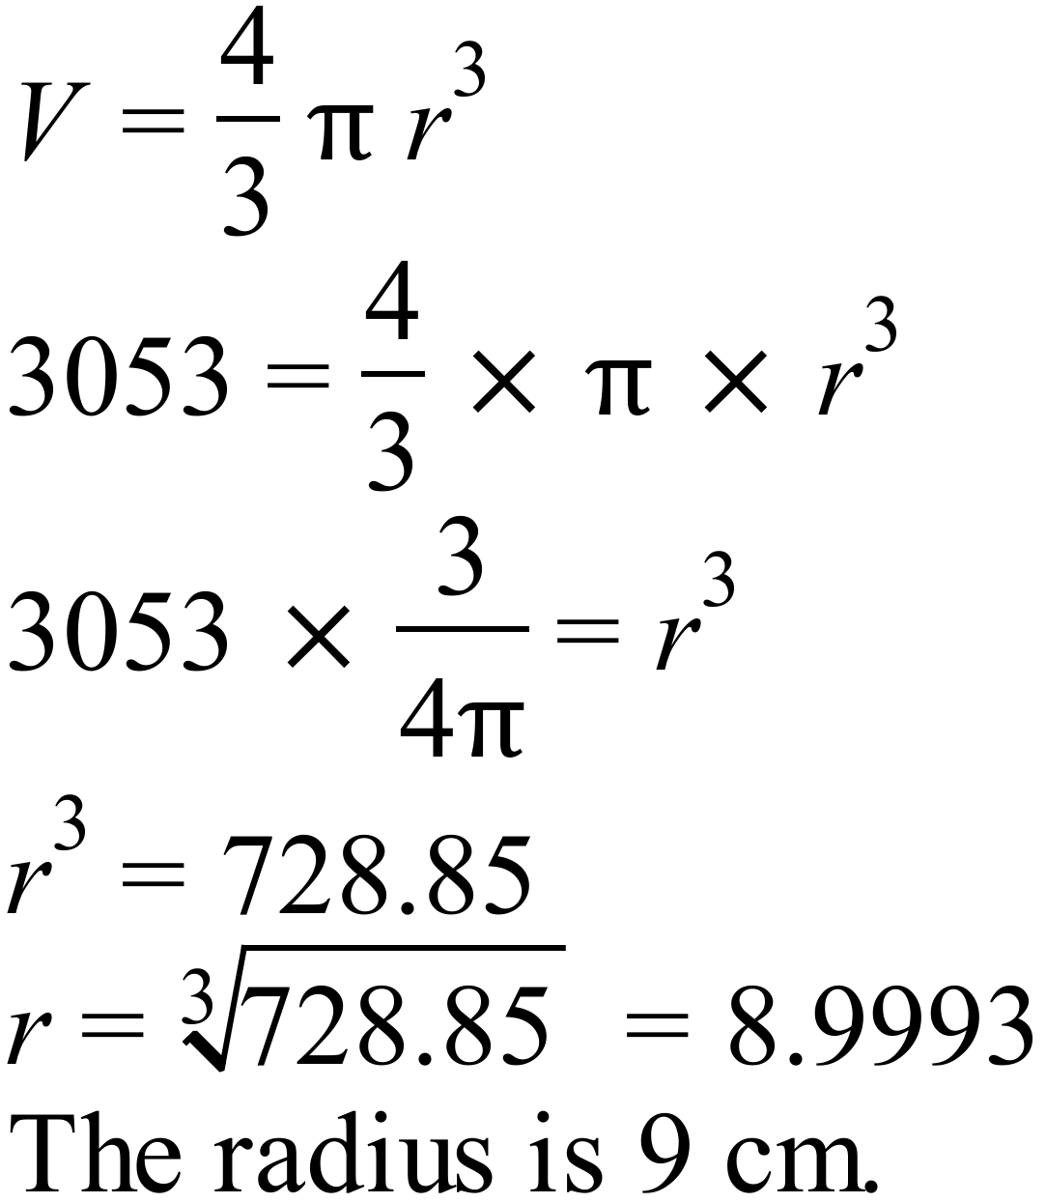 | C
 | 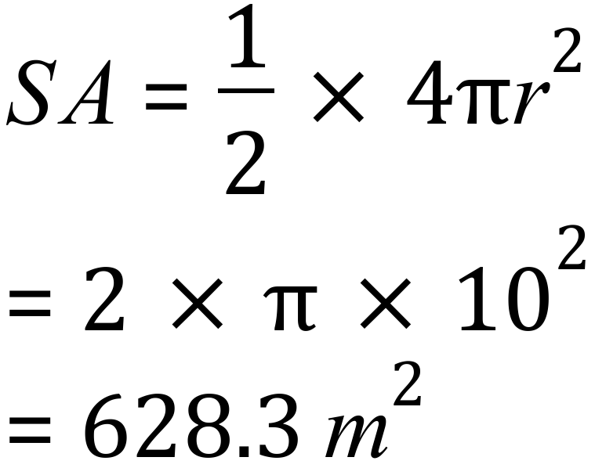 | A
 | 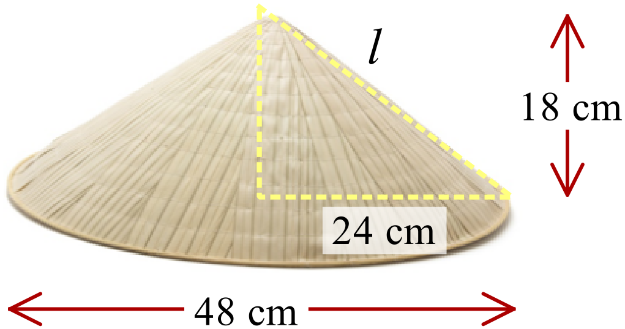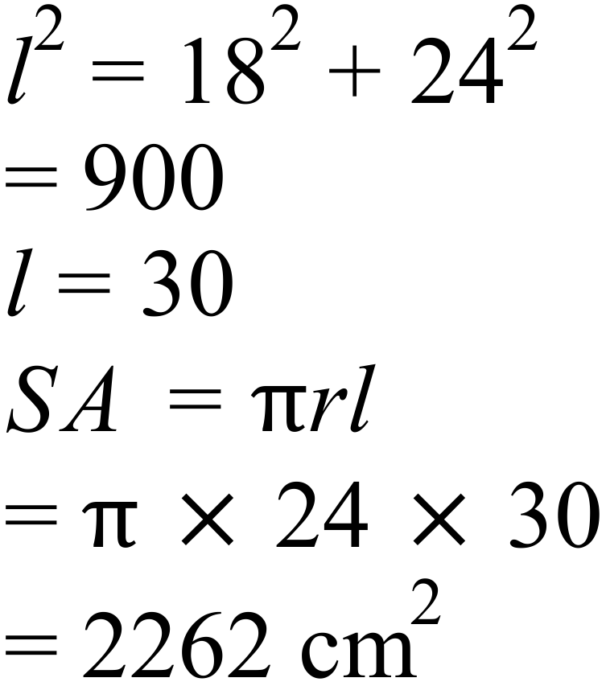 | B
 | 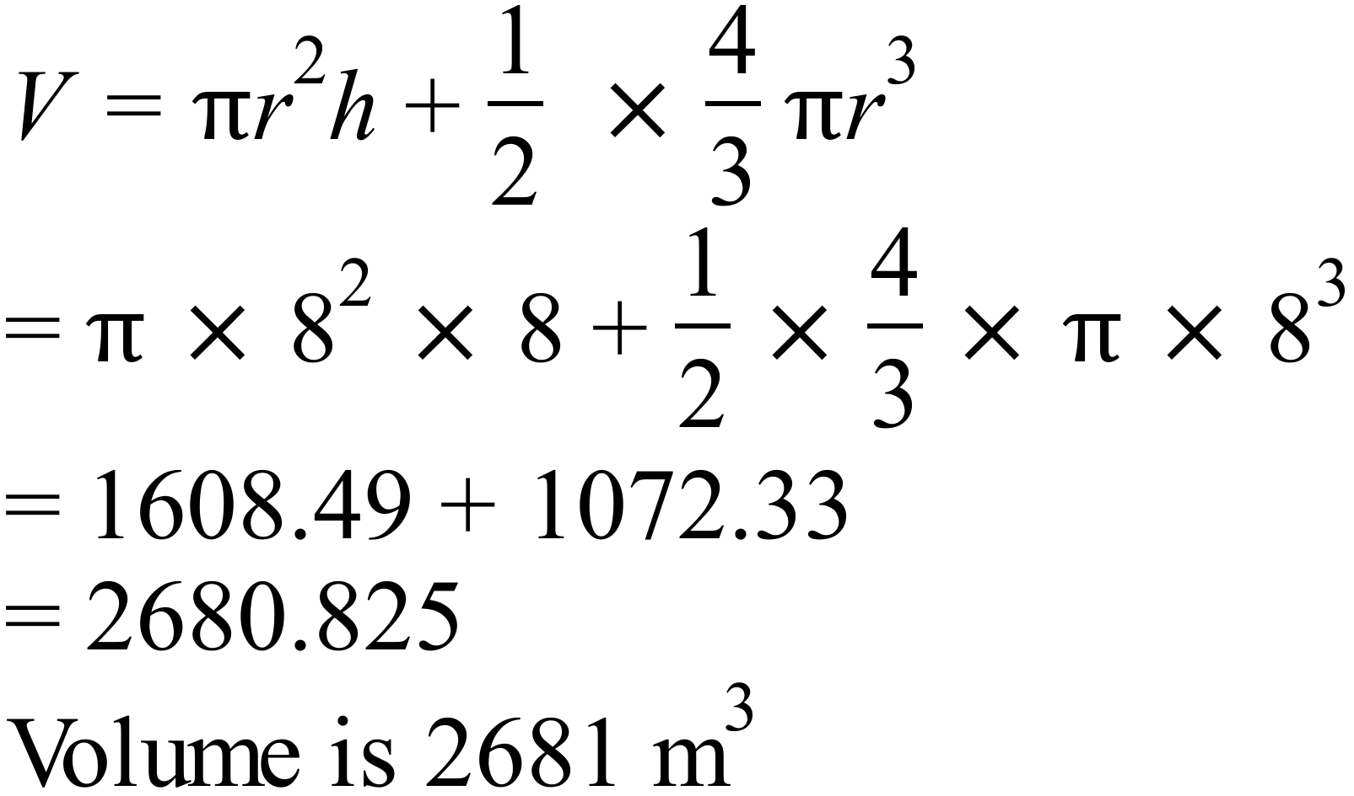 | C
 | 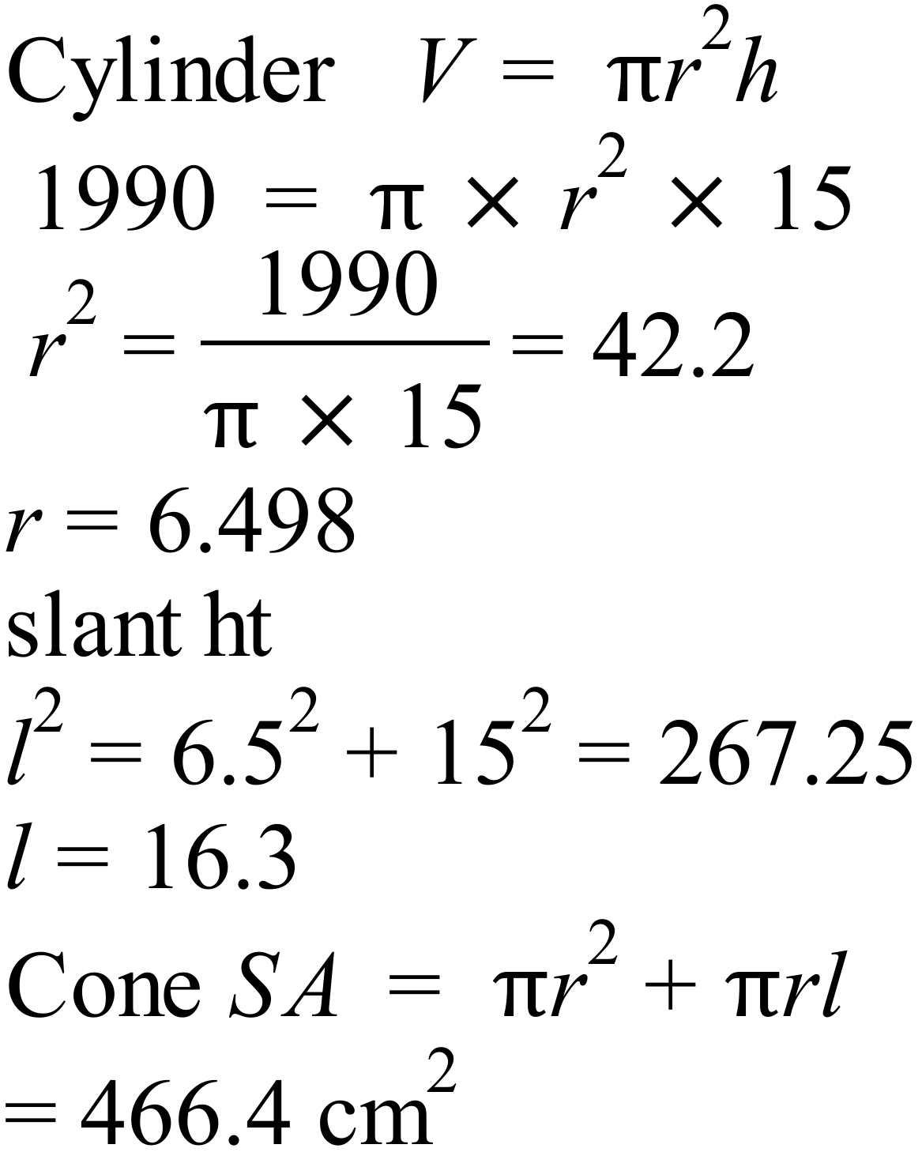 | D

Surface Area and Volume of Other Solids

Multiple Choice Answer Sheet
Name ___ Marking Sheet
Completely fill the response oval representing the most correct answer.

1. A B C D
2. A B C D
3. A B C D
4. A B C D
5. A B C D
6. A B C D
7. A B C D
8. A B C D
9. A B C D
10. A B C D
11. A B C D
12. A B C D

